Project Report

Mean-Shift: Single Object Tracking in Images

Name: Revanth Kalluri
Course: AI & ML (Batch-5)
Problem Statement: Implement a single object tracker using Mean-Shift algorithm.

Prerequisites:
Software used and how I installed them:
Python 3.6: Download and install anaconda using https://www.anaconda.com/download/. After installing anaconda, install below modules(packages), using anaconda prompt to run the commands.
Module | Command
numpy | pip install numpy
cv2 | pip install opencv-python

Pip is a package manager for python packages. Run “pip --version” in anaconda prompt to verify if pip is already installed. Run “conda install pip” to install pip for the first time.

Dataset used:
The data used is the video of a moving ball.

Method used:
Mean shift object tracking algorithm.

1. Importing necessary modules:
2. Read the video and identify Region of Interest:
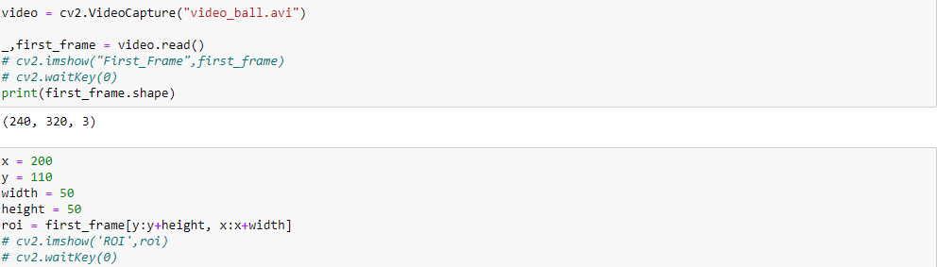
3. Use Mean-Shift for object tracking:
